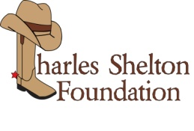

Charles Shelton Foundation Veterinary Scholarship Program

Completed application with your résume, letters of recommendation, and essay must be postmarked no later than April 15th.

Charles Shelton Foundation, attn: Veterinary Scholarship, P.O. Box 2539, Waldorf, MD 20604

All unsolicited material including photos, cover sheets and folders will be discard.
Incomplete and late submissions will be disqualified.

Name:________________________________________________________________

Home Address:_________________________________________________________

City:_________________________________ State:__________ Zip Code_________

Phone:_____________________________E-mail:_____________________________

Current School Attending _________________________________________________

Declared Major ___________________ Grade Point Average ____________________

Signature _____________________________________________ Date ___________

I certify that all information provided in this application is true and correct. I further agree that if I withdraw from school, transfer, or if I am no longer a full-time student during the designated school year, the used balance is forfeitable and I must notify Charles Shelton Foundation, Waldorf MD 20604, within 30 days.

Applicant Signature ________________________________________ Date _________

(Please print a copy for your record as data fields cannot be saved.)
www.thecharlessheltonfoundation.org

